Ch. 13
Bud-rot: Botrytis cinerea and allies

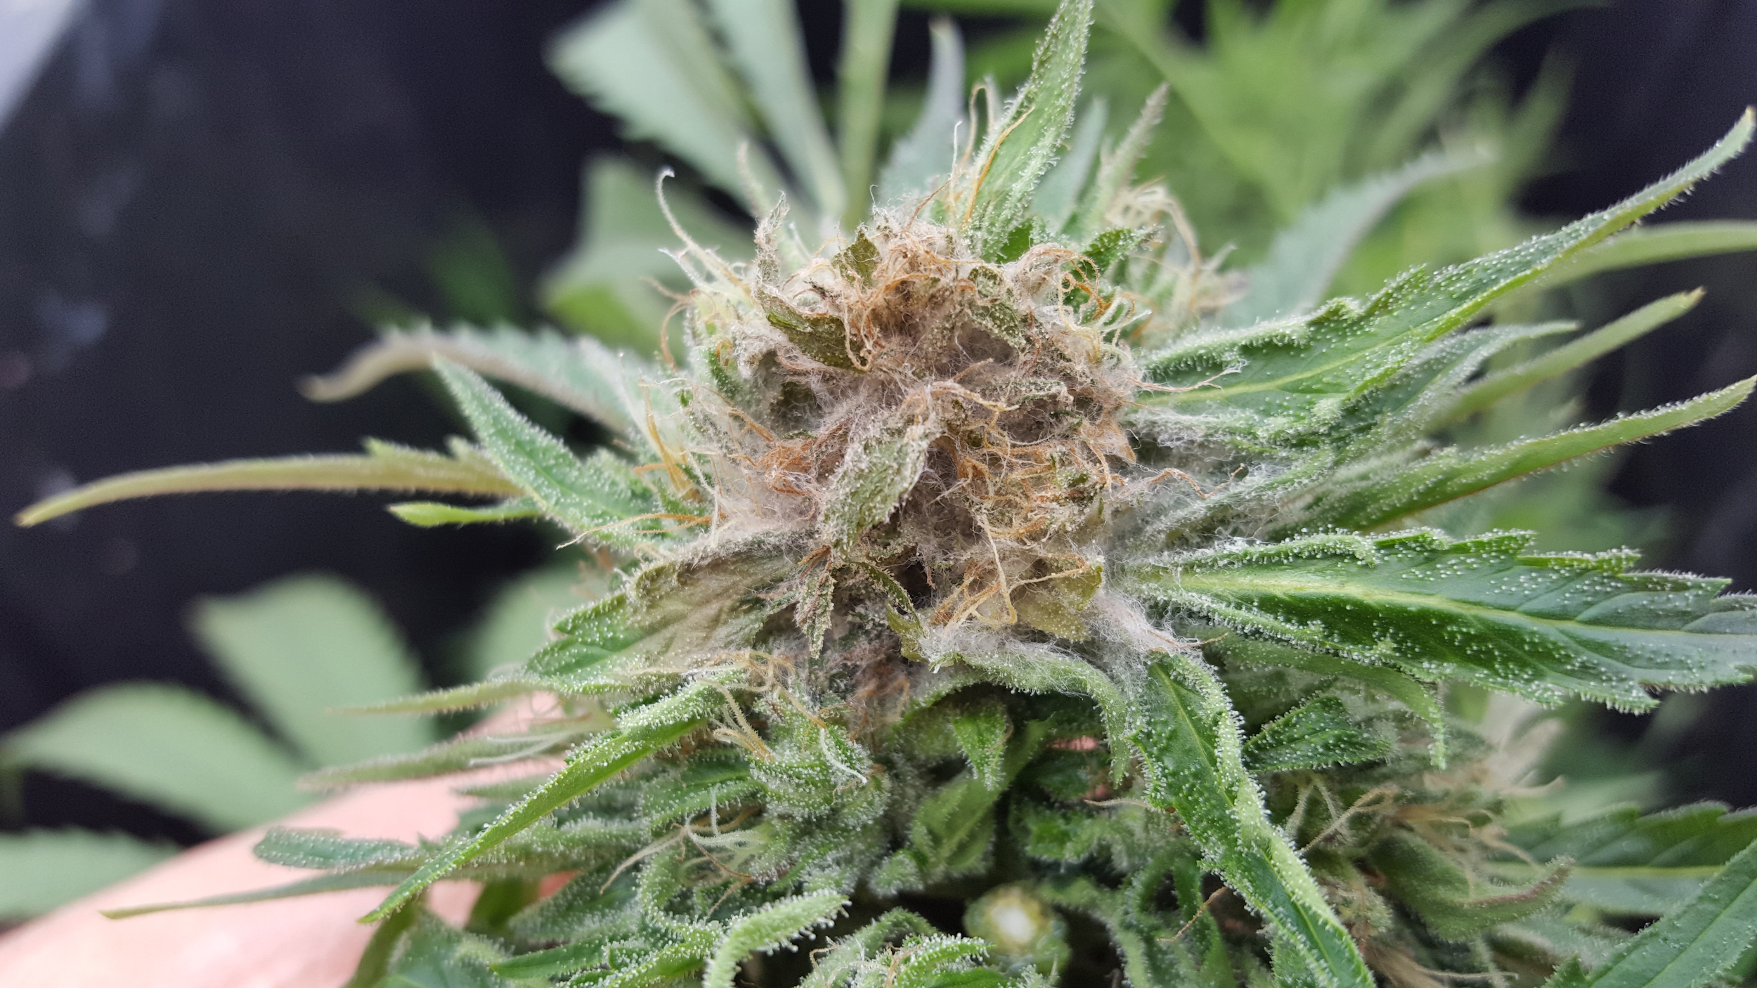
Figure 13.1. Botrytis cinerea growing on mature Cannabis flower.

Taxonomy
Table 12.1
Kingdom: | Fungi | Fungi | Fungi | Fungi | Fungi
Phylum: | Ascomycota | Ascomycota | Ascomycota | Ascomycota | Ascomycota
Class: | Leotiomycetes | Leotiomycetes | Sordariomycetes | Sordariomycetes | Eurotiomycetes
Order: | Helotiales | Helotiales | Hypocreales | Diaporthales | Eurotiales
Family: | Sclerotiniaceae | Sclerotiniaceae | Nectriaceae | Diaporthaceae | Trichocomaceae
Genus: | Botrytis | Sclerotinia | Fusarium | Diaporthe | Aspergillus
Species: | B. cinerea,*  B. pseudocinerea, B. porri | S. sclerotiorum | F. graminearum | D. eres | A. flavus, A. niger, A. terrus, A ostianus, A. fumigatus, ect.
* Botrytis cineria, by far the most common casual organism of budrot, is the asexual stage (anamorph) of Botryotinia fuckeliana. Botryotinia fuckeliana is the corresponding name for the sexual stage (teleomorph) of the same species of fungus. Such duplicate names are the result from the historical develoment of taxonomy, when the sexual and asexual stages of the same species were thought to be different. This fungus is referred to by its anamorph (asexual) name, because the sexual state (Botryotinia fuckeliana) is rarely seen.

Introduction
Another of the infamous fungal foes well known to Cannabis growers is the bud rot causing fungus, Botrytis cinerea. Also known as gray mold, bud rot begins to grow in well developed, mature flowers, capable of devastating maturing crops close to harvest. Therefore, it is important for cultivators to become acquainted with this pathogen and its lifecycle to prevent potential crop loss.
Bud rot is most commonly caused by B. cinerea, though B. pseudocinere, B. porri have also been recently identified to cause disease in Cannabis (Punja and Ni 2021). Grey mold is typically first noticed by yellowing or dying back of leaf or flower tissue. Upon further inspection, one will notice white to gray cotton-like growth coupled with brittle plant material and, if the fungus has matured enough, a dust of spores being released into the wind.
Botrytis is not only feared by Cannabis growers but also by vineyard managers, strawberry growers and many other farmers (although, paradoxically, some vineyards artificially inoculate their grapes with B. cinerea to create the sweet flavors of dessert wine). Botrytis cinerea has been shown to infect over 200 species of plants, including Cannabis sativa (McPartland 1991, Williamson et al. 2007). Therefore, unlike powdery mildew, this fungus is not host specific. Also unlike powdery mildew, Botrytis is not an obligate biotroph, it is a necrotroph. This means that this fungus does not need a living host in order to grow.
When disease symptoms occur, it usually begins with a flourish of growth on dead tissue; the fungus then actively attacks and kills proximate living tissue, if present. In addition to attacking the senescing parts of flowers on mature Cannabis plants, B. cinerea can cause disease among seedlings and even harvested material if it is not properly dried in a timely manner. The versatility of this pathogen's life cycle makes it a risk throughout a plant's life, and beyond. However, systemically infected plants may not exhibit symptoms during vegetative growth.
Because grey mold does not require a live host, it can easily be cultured in vitro. The ability to culture pathogens can be an important asset for research, making them much easier to work with than obligate biotrophs.
Table 13.1. Key difference between Powdery Mildew and Bud Mold
 | Powdery Mildew | Bud Mold
Scientific Name | Erisiphales: Golovinomyces cichoracearum | Botrytis cinerea
Life style | Obligate biotroph | Saprotroph/Biotrophic/Hemibiotrophic/Necrotroph
Systemic | No | Yes
Cutlurable in vitro | No | Yes
Host specificity | Host restricted | Generalist
Age of symptomatic host | All stages of plant growth | Seedling, mature inflorescence, post harvest

Since Botrytis is such a ubiquitous pathogen on a wide variety of crops, it is fairly well studied by the scientific community. Estimates of annual crop loss worldwide due to B. cinerea range from 10-100 billion dollars (Watkinson et al 2016).
Even though there are tremendous resources aimed at understanding and studying Botrytis, farmers are continually struggling with its control. It is best to assume that the pathogen is omnipresent and to be treating your plants prophylactically so that they do not suffer disease symptoms later in life. As with all Cannabis pathogens, increased legalization will increase ambient spore load as well as direct transmissions from farm to farm transport on humans, equipment, and even insect vectors.
Additionally, the large host range of Botrytis allow this organism to persist and spread in areas without historic Cannabis cultivation activities. Having healthy plants and genetic cultivars that are resistant to molds will greatly reduce your risk of disease outbreaks. The environment plays an important role in necrotrophic colonization of the leaf or flower. Active disease is encouraged in humid environments with cool to mild temperatures or with large temperature swings (Elad et al. 2015).


Figure 13.2. Botrytis cinerea asexual reproduction showing the conidiophores that bear all of the conidiospores (conidia 40x).

Biology & Life cycle
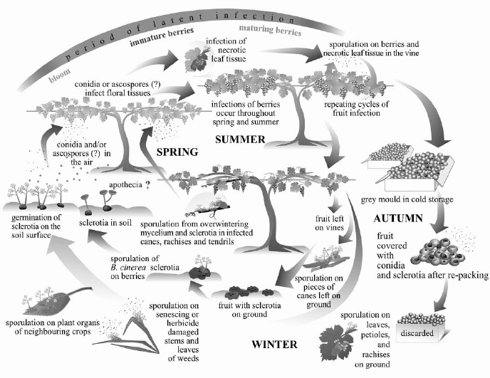
Figure 13.3. Life cycle of B cinerea diagramed on table grape plants (Elmer and Michailides 2007).
The lifecycle of B. cinerea begins with a spore (Fig. 13.4). Usually wind disseminated, though they may also be vectored on or within insects and arthropods. Once the spore is exposed to proper environmental signals, a germ tube will sprout into filamentous hyphae. This hyphae will be monokaryotic, having only one type of nucleus. As the mycelium grows, it will typically consume dead and necrotized tissue, or it may take up residence in a living plant as an endophyte. Botrytis hyphae have simple porate septa, easily seen under magnification, with no clamp connections.
Suitable environments for the formation of a necrotizing infection could be dead plant tissue, such as a senescing stigma or entire, unfertilized pistil (comprising the stigma, style, and ovary); or plant tissue that has been mechanically damaged, such as by herbivory or pruning. Plants weakened by primary infection from some other pathogen or abiotic stressors (temperature, moisture, ect) are also more easily infected.
Botrytis may form seemingly asymptomatic endophytic infections among otherwise healthy plants. A healthy plant may be able to control low level internal infection, or Botrytis may persist in a low virulence state before it switches to actively killing host tissue. When it does switch, it will produce proteins and toxins that kill surrounding plant cells. The non-lethal nutrient transfer between endophytic Botrytis and the host plant turns to a unidirectional flow of nutrients to the pathogen; Botrytis digests then ingests dead and dying host cells, eating the plant from the inside out. The mycelium will continue to grow, killing, then colonizing more and more of the flower.
Increasing evidence of systemic, latent infections of B. cinerea across a variety of species, including Lactuca and Primula (lettuce and primrose), suggests grey mold may colonise healthy plants as a symptomless endophyte (Barnes and Shaw 2002, Shaw et al, 2016). Virulent pathovars may yet have a latent endophyte phase in their lifecycle. Botrytis cinerea living endophytically is likely fulfilling this role as a latent saprobe; colonizing healthy tissue to gain first dibs in exploiting it as a food resource once it becomes weakened or begins to senesce. Botrytis cinerea is often seedborne, usually passed on the outside of the seed coat. Though internal seed infestations have been demonstrated in other plant species, and are likely to occur among Cannabis seeds, internal infections are usually a minor source of seed borne Botrytis infections among crops (du Toit et al. 2004).
Botrytis is able to kill germinating seeds and very young seedlings. Disease at this stage may partly be a function of inoculum density or environmental stressors. Surface sterilization kills the vast majority of seedborne Botrytis inocula, protecting young seedlings during the short window of susceptibility to Botrytis induced damping-off (Sowley et al, 2010). Even if some internally infested seed results in cryptic, systemic infection, these individuals will likely not have any differences in the final amount of disease compared with plants that become infected after germination (Shaw et al. 2016).
Horizontally acquired infections among plants grown from cleaned seed quickly catch up to those resulting from seed borne infections among plants grown from dirty seed. An exception to this may be for growers who are in highly controlled indoor environments following effective clean room procedures; in such cases internal seed infection may become a proportionately more significant source of disease inocula than environmental sources.
Regardless of the source of infection, Botrytis cinerea needs damaged or senescent tissue to cause disease in a mature Cannabis plant. The manner in which Cannabis inflorescences mature results in the presence of susceptible plant parts well before harvest time. As flowers mature, the first to grow will begin to senesce, even though the inflorescence on average is not near maturity (Fig. 12.5). Aging individual flower parts and bracts, particularly senescing stigmas (often incorrectly referred to as the pistils- in fact there is only one pistil per flower comprising two stigmas, the style, and the ovary) are prime plant tissue for active necrotrophy by B. cinerea.

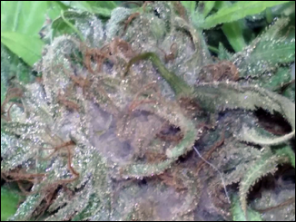
Figure 13.5. Cannabis flower at peak ripeness that is infested with B. cinerea.

Endophytic species considered mutualistic with their host (confir and receive an increase in fitness), are often closely related to pathogenic species. Some mutualist endophytes are even avirulent races of otherwise devastating pathogens (Demers et al. 2015). It is possible that asymptomatic, endophytic infections of Botrytis may represent pathovar-host combinations that include mutualisms. If this is the case, isolates mutualistic in some Cannabis varieties under certain conditions may still be devastatingly virulent when infecting more susceptible Cannabis varieties or under alternate environmental conditions.
It is known, for instance, that disease outbreaks of Botrytis more commonly occur and are more destructive among unhealthy and weakened plants. This has historically been seen as increased susceptibility to new infection. However, if Botrytis is commonly endophytically occurring among Cannabis, as has been shown among a variety of other plant species (Shaw et al, 2016, Barnes and Shaw, 2002), increased disease may result from heightened susceptibility to necrotrophy arising from latent infection rather than, or in addition to, an increased ability of Botrytis to newly infect host tissue. Therefore, heightened susceptibility to bud rot disease among plant hosts weakened by biotic or abiotic stressors likely results from inadequate immune response ability among already infected plants, as well as reduced ability to ward off new infections arising from conidia in the environment.
Current evidence suggests that Botrytis should be classified as a Class 2 endophyte sensu Rodriguez (Rodriquez and Redman, 2008). Class 2 endophytes are characterized by a broad host range; extensive systemic infections of shoot, root, and leaf tissue; and vertical (seed borne) and horizontal (acquired during an individual's lifetime) transmission to new plants.
This fungus can reproduce via sexual and asexual methods. Asexual reproduction consists of the mycelium producing large amounts of clonal spores, called conidia, on specialized hyphal structures, called conidiophores (Fig. 3). These conidia (conidiospores) will be genetically identical to the mycelium that produced them. Botrytis can form both macro- and microcondia. Conidiophore formation is less resource intensive than the formation of sexual fruiting bodies, and does not require the meeting of different mating types. This makes conidia production a very efficient way for the fungus to replicate itself.
When a compatible mating type is nearby, both mycelia will release signals and the two will fuse, anastomize and exchange nuclei. At this point, the fungus is considered a dikaryon and is capable of sexual reproduction, although this may not happen for a long period of time. Botrytis will continue to grow and exist as a dikaryon indefinitely until the environmental cues and signals are received to produce reproductive structures, sexual or asexual. The teleomorph (sexual state) of Botrytis cinerea has a different binomial name, Botryotinia fuckeliana. Because the anamorph was named first and is ubiquitous, whereas the sexual state is rare, Botrytis cinerea takes precedence.
A member of the Ascomycota, B. cinerea forms a specialized ascocarp, called an apothecium, which has an exposed hymenium (spore producing tissue) on its upper surface (Fig. 12.6). When the ascospores are mature, the ascus will burst, releasing the spores into the wind. Formation of the Botryotinia fuckeliana ascocarp (sexual fruiting body) occurs directly from sclerotia formed to survive stressful environmental conditions. These sclerotia are often formed inside plant stems and are the means by which Botrytis overseasons through harsh winters. When weather is adequately warm and moist, an ascocarp emerges from the sclerotia and releases wind dispersed spores. Sclerotia look almost like irregular peppercorn kernels and can vary in shape and size. They will have a melanized rind that protects the internal vegetative hyphae.
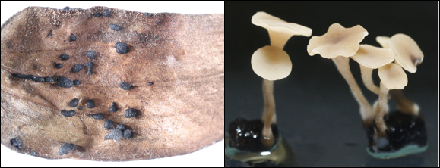
Figure 13.6. Sclerotia of Botrytis cinerea on a dead lily leaf (left) and apothecia of Botrytis cinerea forming out of scleriotia (rightz).

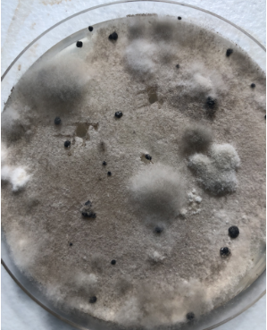
Figure 13.7. Botrytis in culture on potato dextrose agar in a petri dish. Botrytis cinerea grows first as white mycelium in culture, which discolors to gray as it produces conidia. The black structures are melanized sclerotia. Sclerotia serve as resting structures and give rise to sexual fruiting bodies, when they occur.
Botrytis may also survive and replicate itself through the production of chlamydospores (Jarvis 1977). Chlamydospores are asexual, thick walled resting spores of variable size and shape formed at the terminal ends or intercalary in vegetative hyphae. Like other reproductive modes, when chlamydospores germinate on suitable plant tissue, they can infect the host, grow mycelium and even produce conidia. Compared to sclerotia, chlamydospores can only serve as temporary survival structures, helping the fungus overcome short-term harsh conditions.

Prevention & Treatment
Globally, Botrytis is a common pathogen for many Cannabis farmers causing severe crop loss every season. Therefore, by learning about how this fungus grows and reproduces, agronomists and farmers can better understand how to control and possibly prevent infection of plants in the first place. One of the first things we can do is to control our environment and make it less conducive for the fungus to grow. This includes reducing humidity late in flower, avoiding large nighttime temperature drops, and encouraging good airflow through dense canopies. Cultivar susceptibility is likely to be a target area for breeders to focus in order to reduce Botrytis losses.
A key part of any farm's operation is the Integrated Pest Management protocol. Growers should be scouting fields daily and in particular when Cannabis plants begin to flower, looking for senescing leaves and the presence of any pathogens. Researchers have even developed methods for measuring the volatile organic compounds (VOC’s) produced by tomato plants as an indicator for the presence of B. cinerea infection (Jansen et al. 2010). Other research is being conducted for the use of drones in identifying infected crops on field scale and would send instant notification to the farmer (Garzon et al. 2019). Until more sophisticated methods are developed for determining infection in Cannabis crops, growers must rely on traditional scouting for monitoring disease.
Keeping plants clean by removing dead leaves and unhealthy plant material can reduce infection by removing food sources for these fungi (Williamson et al. 2007). Even if endophytic infections are common, the easily available nutrient resources of dead plant material allow Botrytis to become necrotizing by overwhelming a plant with inocula and direct attacks.
When growing plants outdoors, it is important to control insect pests among the flowering plants. In particular, certain caterpillars are attracted to Cannabis inflorescences, tunneling into flowers and leaving mazed routes of plant litter and excrement, a prime condition for a secondary infection. Botrytis then quickly colonizes the dead material and nutrient rich caterpillar frass, permitting the fungus to launch an attack resulting in a necrotrophic disease that kills a much larger portion of the flower than the caterpillar had damaged. Using biological preventatives like Bacillus thuringiensis kurstaki (Btk) can reduce attack by the caterpillars, which will then reduce the risk of Botrytis (Ignoffo et al. 1977).

Table 13.2. Fungicidal products effective against B. cinerea.
Product | Active ingredient(s) | Mode of action
- Serenade  - Cease | Bacillus subtilus | - Direct competition  - Activates induce plant resistance (ISR)
- ZeroTolerance  - Method1  - Essential oils | Thyme oil, peppermint oil, rosemary oil, clove oil, garlic oil, sesame oil | - All have varying degrees of antifungal properties
- Nuke ‘em  - Dr. Zyme | Citric acid (maybe other active ingredients) | - Citric acid has some antifungal properties, but it varies fungus to fungus and is usually not very effective
- Oxidate 2.0  - Zerotol 2.0  - Jet-AG | Hydrogen dioxide, Peroxyacetic acid | - Oxidizing agent that destroys cell membranes and DNA
- Botector | Aureobasidium pullulans | - Direct competition for space

Botrytis is fairly easy to identify on Cannabis. If it is on a seedling, the seedling will usually die soon after emergence and there is not much growers can do once the fungus is detected. If you are planting future seeds from the same batch or lot, you can surface sterilize the seeds by rinsing with a 10% household bleach solution for 30 seconds (Table 12.2). There is also some promise in seed treatments with Trichoderma fungi (ex. RootShield WP) (Meyer et al. 1998).

Table 13.3. Procedure for chemical and biological treatment of contaminated seeds.
Seed treatment options
Chemical | Biological
- Make a 10% bleach solution by adding 10 mL of household bleach to 90 mL of water.  - Put seeds in a small jar  - Pour bleach solution over seeds  - Swirl around for 30 seconds  - Empty bleach solution while keeping seeds in the jar  - Pour water into jar and swirl for 30 secs  - Empty water from seeds and repeat 2x times with water  - Directly sow into growing medium | - Prepare a spore suspension by purchasing a product containing the organism you want to coat seeds with.  - Place seeds to be treated in spore suspension and swirl for 1-2 minutes  - Remove seeds from spore suspension  - Directly sow seeds into growing medium

Treating flowers infected with Botrytis can be difficult because typically growers do not want to spray flowers with anything. Therefore, preventative sprays, controlling the environment (especially late in flower), and growing resistant genetics are all key to protecting your plants from fungal attack. Using biocontrol agents to reduce secondary infections from insect vectors can also reduce disease incidence.
By keeping environmental conditions in check, growers reduce the chance that they will encounter this fungus. Botrytis cinerea has hydrophobic spores and does not grow well in dry conditions (45% RH or lower)(Prins et al. 2000). Therefore, keeping your environment at this humidity will reduce this pest pressure, though this is generally lower than preferable for optimum Cannabis growth (Williamson et al. 1995). Also, having lots of air movement, both horizontal and vertical, can reduce the likelihood of spores landing on susceptible plant tissue (Elad 2015).
Another environmental pressure that this fungus does not like is high light conditions (Elad 2015). Having an even distribution and the appropriate quantity of light in a grow can also reduce fungal attacks. In fact, Rotem and Aust in 1991 documented that the conidiospores of Botrytis were only able to survive for a matter of minutes under the Israeli sun at midday. Clearly, this is not always the case, otherwise outdoor growers, growing under direct sunlight in places like Southern Oregon or Northern California would never get this pathogen, and they do.
Some farmers attempt to cut out sections of flowers that are infected with Botrytis with the hope of preventing the spread of this fungus. While this may help some proximate spread, ultimately the spores are in the environment, and if the fungus can be seen growing, the plants have already been exposed to this pathogen. If endophytic infections are responsible for disease outbreaks, this practice may not actually help at all. If one is to attempt to cut out the fungus from the flower, it is recommended to place the cut flower immediately into a plastic bag to reduce spore spread. Also wipe down any scissors with isopropyl alcohol as well.
There is interest in biocontrol of B. cinerea, using organisms (fungi, bacteria) to control the spread of the pathogen. The fungus Aureobasidium pullulans, which is an Ascomycete fungus that is able to out compete Botrytis for growing space and resources, can prevent gray-mold from forming. Trapman et al. 2010 found that applying a product containing A. pullans in combination with hot water treatments reduced post-harvest contamination from several fungi, including B. cinerea (Trapman et al. 2010).
Another BCA of B. cinerea worth exploring further with Cannabis cultivation is Ulocladium atrum. Researchers have been experimenting using this antagonistic fungus as a biocontrol of B. cinerea in strawberry fields with some success (Boff et al. 2002). Not surprisingly, they found that applying U. atrum to the plants beginning at an early stage showed better efficacy than applying the antagonist only once the plants start flowering and show symptoms of the disease. Other studies have also demonstrated U. atrium’s ability to significantly reduce the sporulation of and crop loss to B. cinerea when the plants were treated with a solution of U. atrum (Kohl et al. 1998).
Other fungi that are antagonistic to B. cinerea that are worth further research with Cannabis include Gliocladium roseum and Trichoderma hazarium (Sutton et al. 1997, De Meyer et al. 1998). Increased research into antagonistic microbes will surely reveal more potential BCAs active against Botrytis.

